Add the new Section 718 to the Standard Specifications as follows:

718.01 General. This work consists of the furnishing all labor, supplies, equipment and materials and performing all operations in connection with the installation of locatable underground facilities, as shown on the plans, and specified and directed by the Engineer to comply with C.R.S. 9-1.5-103(10). The statute requires that all new underground facilities, including laterals up to the structure or building being served, installed on or after August 8, 2018, must be electronically locatable.

718.02 Tracer Wire

All tracer wire shall have HDPE insulation intended for direct bury and color-coated per the APWA standard for the specific utility being marked.

- Open Trench - Tracer wire shall be #12 AWG copper clad steel, high strength with minimum 450 lb break load, with minimum 30-mil HDPE insulation thickness.
- Directional Drilling/Boring - Tracer wire shall be #12 AWG copper clad steel, extra high strength with minimum 1,150 lb break load, with minimum 30-mil HDPE insulation thickness.
- Pipe Bursting/Slip Lining - Tracer wire shall be 7 x 7 stranded copper clad steel, extreme strength with 4,700 lb break load, with minimum 50-mil HDPE insulation thickness.

718.03 Tracer Wire Installation (Refer to Figure 1 and 2)
- Install tracer wire to allow proper connection access of line tracing equipment, proper locating of wire without loss or deterioration of low frequency (512Hz) signal for distances more than 1,000 linear feet, and without distortion of signal caused by multiple wires being installed in close proximity to one another.
- Tracer wire systems must be installed as a single continuous wire, except where using approved connectors. No looping or coiling of wire is allowed.
- Any damage occurring during installation of the tracer wire must be immediately repaired by removing the damaged wire and installing a new section of wire with approved connectors. Taping or spray coating shall not be allowed.
- Tracer wire shall be installed at the top of the pipe and secured (taped or tied) at 5-foot intervals.
- Tracer wire must be correctly grounded as specified.
- Tracer wire on all service lateralsand stubs must terminate at an approved tracer wire access box located directly above the utility, at the edge of the road right-of-way but out of the roadway. (See Termination/Access)
- At all mainline dead-ends, tracer wire shall go to ground using an approved connection to a drive-in magnesium ground rod, buried at the same depth as the tracer wire. (See Grounding)
- Mainline tracer wire shall not be connected to existing conductive pipes. Treat as a mainline dead-end and ground using an approved waterproof connection to a ground rod buried at the same depth as the tracer wire.
- All service lateral tracer wires shall be a single wire, connected to the mainline tracer wire using an approved mainline-to-lateral lug connector, installed without cutting or splicing the mainline tracer wire.
- In occurrences where an existing tracer wire is encountered on an existing utility that is being extended or tied into, the new tracer wire and existing tracer wire shall be connected using approved splice connectors and shall be correctly grounded at the splice location as specified.

718.04 Utility Infrastrucute (Refer to Figure 1 and 2)
- All service lateral tracer wires must be correctly connected to the mainline tracer wire to ensure full tracing and locating capabilities from a single connection point.
- Lay mainline tracer wire continuously, by-passing around the outside of manholes and structures on the north or east side.
- Tracer wire on all utility laterals must terminate at the property line with a coil of 6 feet of tracer wire taped directly to the service lateral, at the edge of the road right-of-way or at an approved location.
- CDOT’s Project Engineer must be contacted to inspect tracer wire installation prior to backfilling any infrastructure that connects to the agencies utility infrastructure.

718.05 Connectors (Refer to Figure 1 and 2)

- Mainline tracer wire - All mainline tracer wires must be interconnected in intersections, at mainline tees and mainline crosses. At tees, the three wires shall be joined using a single 3-way lockable connector (SnakeBiteTM or approved equal). At crosses, the four wires shall be joined using a 4-way connector. Use of two 3-way connectors with a short jumper wire between them is an acceptable alternative.
- Direct bury wire connectors – Direct bury wire connectors shall include 3-way lockable connectors (or approved equal) and mainline-to-lateral lug connectors specifically manufactured for use in underground tracer wire installation. Connectors shall be dielectric silicon filled to seal out moisture and corrosion and shall be installed in a manner so as to prevent any uninsulated wire exposure. Non-locking friction fit, twist-on or taped connectors are prohibited.

718.06 Termination/Access (Refer to Figure 1 and 2)

- All tracer wire termination points must use an approved tracer wire access box (above ground access box or grade level/in-ground access box as applicable), specifically manufactured for this purpose.
- All grade level/in-ground access boxes shall include a dual terminal switchable lid (SnakePitTM LD14G2T-SW or approved equal), be appropriately identified with “sewer” cast into the cap, and color coded per APWA standard for the specific utility being marked.
- A minimum of 2 feet of excess/slack wire is required in all tracer wire access boxes after meeting final elevation.
- All tracer wire access boxes must include a manually-interruptible conductive/connective link between the terminal(s) for the tracer wire connection and the terminal for the ground rod wire connection.
- Ground wire shall be connected to the identified (or bottom) terminal on all access boxes.
- Service Laterals on public property - Tracer wire must terminate with a coil of 6 feet of tracer wire for future extension to the building, located at the edge of the road right-of-way, and out of the roadway.
- Service Laterals on private property - Tracer wire must terminate at an approved above-ground tracer wire access box, affixed to the building exterior directly above where the utility enters the building, at an elevation not greater than 5 feet above finished grade, or terminate at an approved grade level/in-ground tracer wire access box, located within 2 feet of the building being served by the utility.
- Long-runs, in excess of 2,500 feet - Tracer wire access must be provided utilizing an approved grade level/in-ground tracer wire access box, located at the edge of the road right-of-way and out of the roadway. The grade level/in-ground tracer wire access box shall be delineated using a minimum 48inch polyethylene marker post, color coded per APWA standard for the specific utility being marked.

718.07 Grounding (Refer to Figure 2)

- Tracer wire must be correctly grounded at all dead ends andstubs.
- Groundtracer wire by using a drive-in magnesium ground rod with a minimum of 20 feet of #12 red HDPE insulated copper-clad steel wire connected to the anode (minimum 1.5 lb) specifically manufactured for this purpose and buried at the same elevation as the utility.
- Install the ground rod in a direction 180 degrees opposite of the tracer wire, at the maximum possible distance.
- When grounding the tracer wire in areas where the tracer wire is continuous and neither the mainline tracer wire or the ground rod wire will be terminated at or above grade, install ground rod wire directly beneath and in-line with the tracer wire. Do not coil excess wire from ground rod wire. In this installation method, the ground rod wire shall be trimmed to an appropriate length before connecting to tracer wire with a mainline to lateral lug connector.
- Where the ground rod wire will be connected to a tracer wire access box, a minimum of 2 feet of excess or slack wire is required after meeting final elevation.

718.08 Prohibited Products and methods shall not be allowed or acceptable:
- Uninsulated tracer wire
- Tracer wire insulations other than HDPE intended for direct bury.
- Tracer wires not domestically manufactured
- Non-locking, friction-fit, twist-on or taped connectors
- Brass or copper ground rods
- Wire connections utilizing taping or spray-on waterproofing
- Looped wire or continuous wire installations, that has multiple wires laid side-by-side or in close proximity to one another
- Tracer wire wrapped around the corresponding utility
- Brass fittings with tracer wire connection lugs
- Wire terminations within the roadway, (in valve boxes, cleanouts, manholes),
- Connecting tracer wire to any conductive utilities

718.09 Tracer Wire Receiver

Receiver Antennas | Two sets of Omnidirectional Antennas each comprising:  - Two Compass antennas  - Two Horizontal antennas  - Two Vertical antennas
Batteries | - Alkaline batteries  - Rechargeable Lithium-ion batteries
Battery Life | - Alkaline – typically 12 hours intermittent use at 70ºF (21ºC)  - Lithium-ion – typically 27 hours intermittent use at 70ºF (21ºC)
Temperature Range | - Operating: -4ºF to 122ºF (-20ºC to 50ºC)  - Storage: -40ºF to 140ºF (-40ºC to 60ºC)
Compliance and Approvals | - Complies with FCC Rules Part 15  - CFR 47 part 2  - CFR 47 Part 15

Information Displayed | Status Bar Information:  - Antenna configuration: Peak, Peak with arrows, Broad Peak, Null, Delta Null, Omni Directional Peak (if appcliable) , Omni Directional Broad (if applicable)  - Line location - depth & current measurement  - Battery condition  - Speaker volume  - Bluetooth and GNSS status  - Radio link to transmitter status  - Signal strength - moving bar graph & numeric value  - Bar graph color-coded indicating distortion level  - Peak level indicator  - Proportional left/right indication  - Compass: full 360°-line direction indicator  - Gain level (in dB)  - Frequency selected  - Configuration menus including GNSS status and data logging transfer status  - Depth and current  - Warnings (if activated)  - GPS coordinates  - Signal current and depth value  - Log number  - Warnings (Excessive Tilt, Overhead Signal, Shallow Cable, Signal Overload)  - Auto shut down – configurable to power down at five minutes, ten minutes, or never
Data Logging | - Capable of 50 million record internal storage  - The ability for data to be transferred via cellular or Bluetooth connectivity, into the cloud using CDOT approved software  - All parameters stored at each location including depth, current, date, time, mode, gain setting, frequency, locate uncertainty, longitude, latitude, and height above sea-level

Operating Frequencies | - Configurable frequencies from 98Hz to 200 kHz  - Power 50Hz and 60Hz  - Radio 10.0kHz - 22.7kHz bandwidth
Operating Modes | - Peak, Peak with arrows, Broad Peak  - Null, Delta Null  - Omni Directional Peak, Omni Directional Broad (if applicable)
Accuracy | Locate pinpointing accuracy: | - Over 9ft (3m) – 5% of the depth  - Up to 9ft (3m) – 3% of the depth
 | Depth measurement accuracy: | +/- 5% of depth
 | Current measurement accuracy: | - 5% of actual current – over 9ft (3m)  - 3% of actual current – up to 9ft (3m)
 | Depth range: | Dependent on the strength of the signal radiating to the locator
 | * Performance rated using a single undistorted signal source

718.08 Tracer Wire Transmitter

Power Options | - Alkaline battaries  - 12~22V external DC power  - Optional Li-Ion rechargeable battery
Battery Life | Output Power Alkaline Li-Ion (Rechargeable)  1 watt 25 hours 50 hours  5 watt 6 hours 10 hours  10 watt 4-5 hours 6 hours
Temperature Range | - Operating: -4ºF to 122ºF (-20ºC to 50ºC)  • Storage: -40ºF to 140ºF (-40ºC to 60ºC)

Information Displayed | - Current (numeric)  - Volts  - Resistance  - Frequency of output signal  - High voltage warning if volts online exceed 30V AC  - Beeper volume  - Battery condition icon  - Bar graph showing the proportion of successfully applied signal  - Confirming connection mode (Direct connection)
Direct Connection Mode | Available frequencies between 98Hz and 200 kHz with default frequencies of 512Hz,  8.19 kHz, 33 kHz, 65 kHz, 200 kHz
Transmitting Mode Power Output | In accordance with FCC part 15:  - Frequencies under 45 kHz - 10 watts  - Frequencies over 45 kHz - 1 watt
Maximum Output Voltage | 50V RMS
Maximum Output Current | 1A RMS constant current
Output Protection | Output protected against accidental momentary connection to up to 240V AC
Temperature Range | - Operating: 14ºF to 140ºF (-10ºC to 60ºC)  • Storage: -4ºF to 140ºF (-20ºC to 60ºC)  • Charging: 32ºF to 113ºF (0℃ to 45℃)

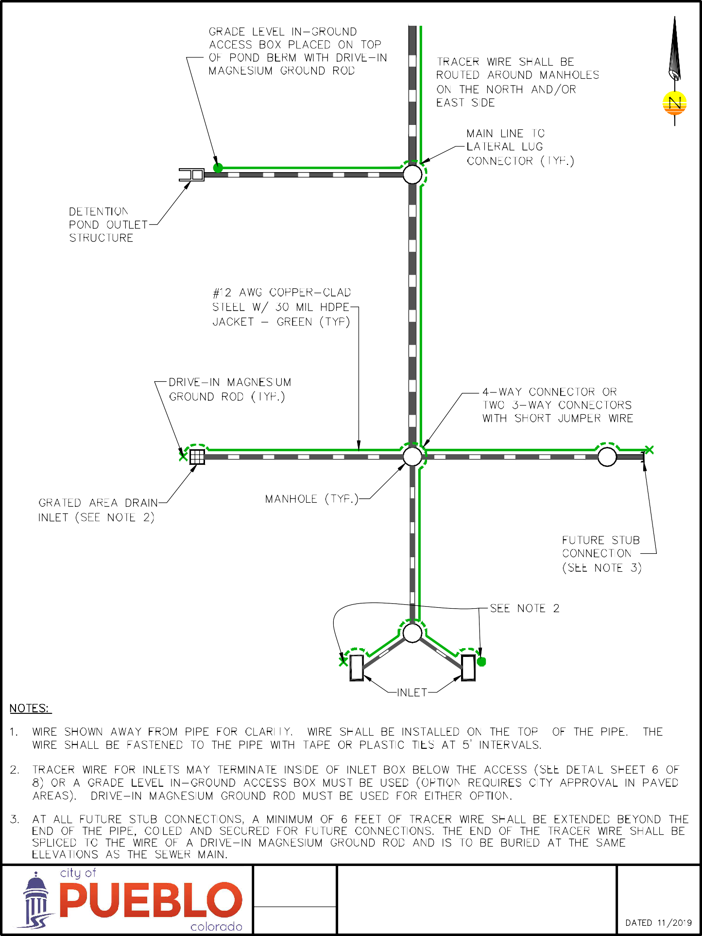
Figure 1

Figure 2

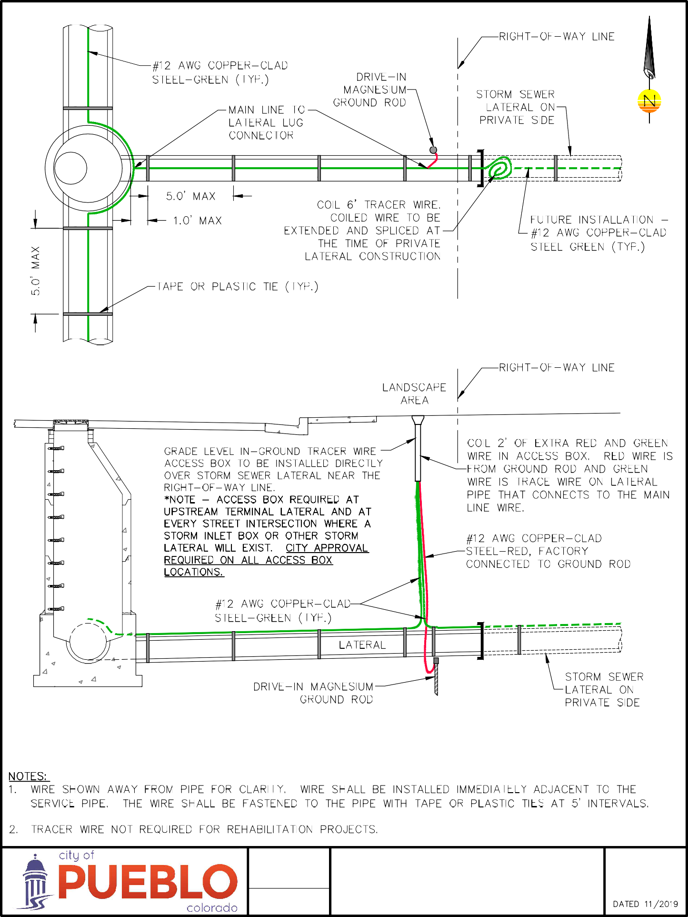

718.10 Testing Tracer Wire Signal

- All new tracer wire installations shall be located using typical low frequency (512Hz) line tracing equipment, witnessed by the Contractor, the Engineer and the Facility Owner as applicable, prior to acceptance of ownership. This verification shall be performed upon completion of rough grading and again prior to final acceptance of the project. Continuity testing in lieu of actual line tracing shall not be accepted.

Electronic RFID Marking And GPS Based Utility As‐Built Mapping System

718.11 RFID Installation

The RFID markers are placed at 25-foot increments, when there is a horizontal or vertical line change, change in pipe size or number of conduits. They will also be placed at crossings of existing utilities, ends of casings, specified fittings and as determined by the Engineer. The ball markers will be placed during the backfill operation of the facility with a minimum 3-foot cover for roadway applications and a maximum 5-foot depth; near surface pendants are placed at the end of every other rod length for directional drilling operations with a minimum depth of 1 foot in non‐roadway applications and a maximum depth of 3 feet in roadway crossings. During the test pitting for the directional drilling operation, ball markers will be placed on the existing utility crossings. Ball and near surface pendants will be placed on conduit sweeps at 10-foot increments which is the minimum spacing for all types of markers of the same frequency.
The frequency of the RFID Marker is based upon the specific utility that is being installed as dentified in Table 1.
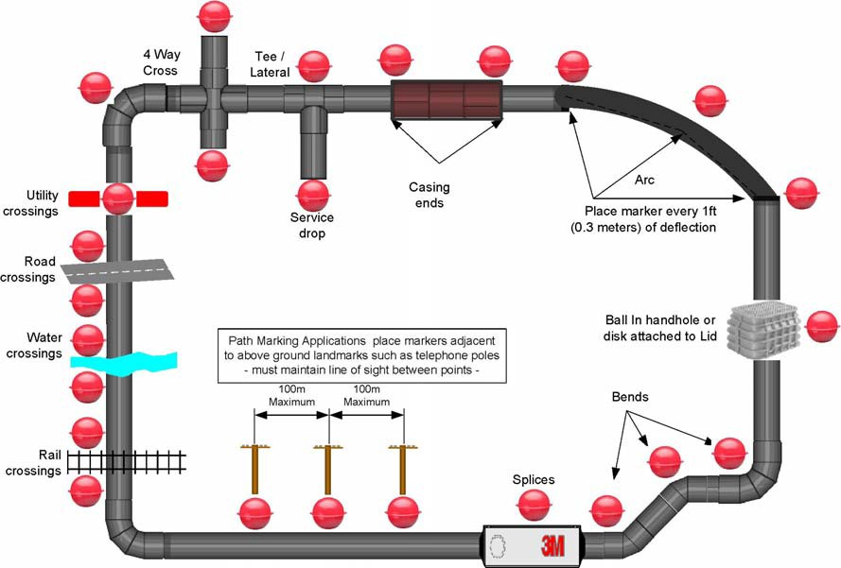
The information that is programmed into the RFID attribute of the ball or near surface pendant will be established and agreed upon by the specific Utility Company and or the Department prior to installation.

Table 1
MARKER TYPES AND FREQENCIES
TYPE | COLOR | FREQUENCY
UNDERGROUND
RFiD Ball Marker Telecommunications | ORANGE | 101.4khz, to be used for copper and fiber optic cable systems that connect to the telephone facilities
RFiD Ball Marker Power | RED | 169.8khz, to be used for all electrical power systems
RFiD Ball Marker Water | BLUE | 145.7khz, to be used for all water mains and services as well as all appurtenances
RFiD Ball Marker Wastewater | GREEN | 121.6khz, to be used for all mains and services.
RFiD Ball Marker Gas | YELLOW | 83khz, to be used for natural gas and liquefied petroleum mains and services.
RFiD Ball Marker Cable TV and communications | BLACK/ORANGE | 77khz, to be used for copper and fiber optic cable systems that are independent communications system.
RFiD Ball Marker General purpose and reclaimed water | PURPLE | 66.35khz, to be used to identify abandoned facilities and signs as well as other underground and/or above ground facilities that are to be mapped or inventoried.
NEAR SURFACE
RFiD Near Surface Peg Pendant, Telecommunications | ORANGE | 101.4khz
RFiD Near Surface Peg Pendant, Power | RED | 169.8khz
RFiD Near Surface Peg Pendant, Water | BLUE | 145.7khz
RFiD Near Surface Peg Pendant, Wastewater | GREEN | 121.6khz
RFiD Near Surface Peg Pendant, Gas | YELLOW | 83khz
RFiD Near Surface Peg Pendant, Cable TV and communications | BLACK/ORANGE | 77khz
RFiD Near Surface Peg Pendant, General purpose and reclaimed water | PURPLE | 66.35khz

ELECTRONIC RFID MARKERS

MARKER BALLS AND NEAR SURFACE PENDANTS:electronic markers shall be RFID “Programmable” markers. The markers shall be the 4 inch round ball type, 5-foot depth for read/locate/depth (see Figure 3) or the near surface marker pendant type, 3-foot depth for read/locate/depth (See Figure 4).

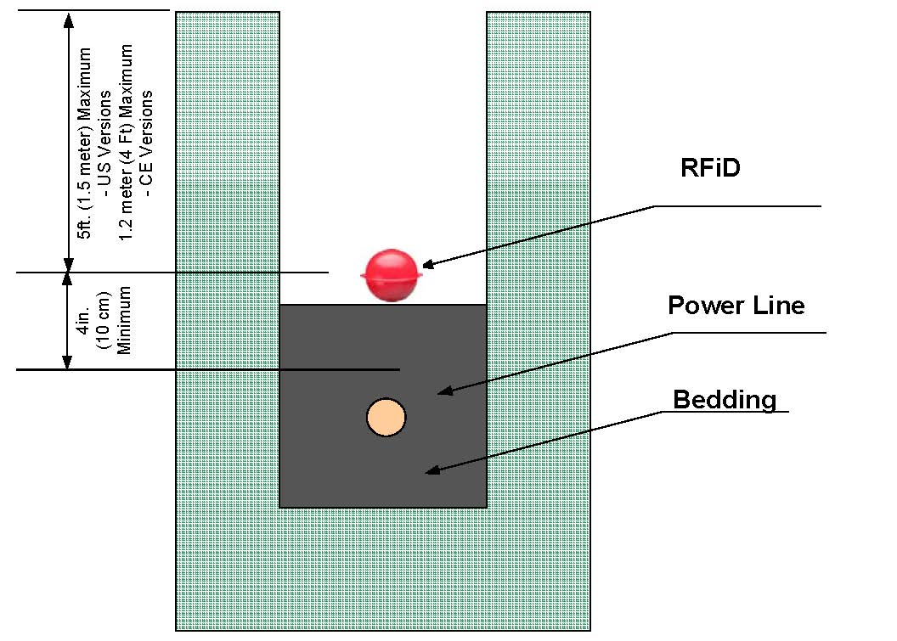
Figure 3

RFID MARKER BALLS AND NEAR SURFACE PENDANTS

The uses of the specific near surface pendants shall be the same as the ball markers. The near surface pendants are to be used to record the horizontal and vertical location of facilities that are installed by the use of a directional drill or case boring operations

Figure 4
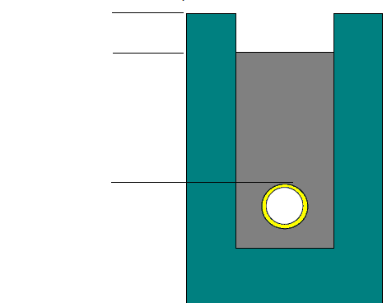
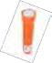
Maximum Depth
2 feet and must be installed vertically
Depth varies on
required cover

Operating temperature | ‐20° C to 50° C (‐4° F to 122° F)
Storage temperature | ‐20° C to 70° C (‐4° F to 158° F)
Marker compatibility | All RFID markers (telephone, gas, communication, power, water, wastewater and general purpose)
Dual marker mode | Any two marker frequencies simultaneously
Detection range | Exceeds maximum marker depth specifications
Marker read range | (5 ft) to all RFID ball markers, (3 ft) to all RFID near surface markers (peg markers)
Marker write range | (1 ft)
RFiD Marker depth measurement accuracy | +/‐ 5 cm (2 in) (+/‐ 10% ) up to marker depth specifications
Memory storage with date/time stamp | Read marker records 100, Written marker records 100, User defined iD templates 32
Marker depth memory storage | Five with date/time stamp
Power | Battery type: eight AA size, alkaline; Typical battery life: 25 hours
Display | Large graphic high‐contrast LCD with backlight
Speaker | 0.25W
Headphone jack | Standard mini‐jack
Serial port | Standard RS232 serial with DB9 connector

718.15 Packaging
- Marker balls shall come packaged 30/box.
- Marker pendants shall come packaged 50/box.

718.16 RFID Locator For Cable/Pipe/Electronic Marker

The marker locator shall be capable of locating all types of underground pipes and cables, using the portable battery operated transmitter. The locator shall also be capable of reading and writing template data to and from the markers. Information such as a pre‐programmed unique identification number, facility data, owner information, and application type from up to 100 markers shall be stored with date/time stamp, and transmitted back to the user’s PC through a standard RS232 serial port. The software shall be included with each electronic marker locator.

718.17 Centeral Mapping Software and Handheld GPS Devices:

A Central Mapping Software used or approved by the Department shall be used to import data from a handheld GPS devices that contains data collected from the field operations including RFID and Tracer Wire testing. The contractor shall use an approve locator, handheld GPS device, and the and the Departments mobile software to provide a data base of electronic markers, tracer and wire signal testing. The data shall also include matched GPS coordinates of each test section with decimenter horizontal and vertical accuracy. The handheld GPS devices shall have integrated software to facilitate mapping the marker template information. ESRI Shape Files for ARCGIS, KML using Google Earth/Map are acceptable deliveriables is approved by the Project Engineer. This electronic as-installed information will be provided to the Department within 10 days of the completion and acceptance of the utility system.

